Ryan Stearns  
Lab 5  
CNA 432

**IPv6ExtHdrRouting Script**

#! /usr/bin/env python

#Set log level for Scapy Warnings

import logging

logging.getLogger("scapy").setLevel(1)

from scapy.all import *

x = IPv6(dst='2001::a6b8', src='8008::b8b8')

payload = "far.run" * 50

y = ICMPv6EchoRequest (data=payload)

z = IPv6ExtHdrRouting(addresses=['2001::a6b8', '2001::c9ff'])

packet = x/z/y

packet.show2()

send(packet)

**IPv6ExtHdrRouting Script Run**

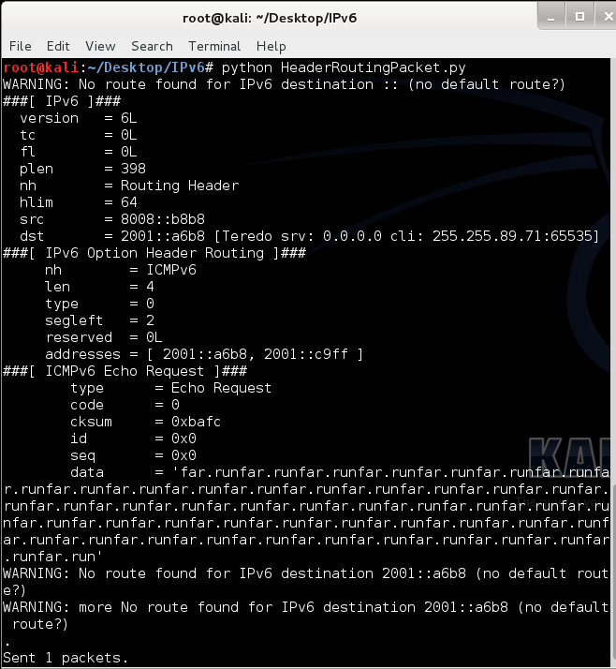

**IPv6ExtHdrRouting Wireshark Capture**

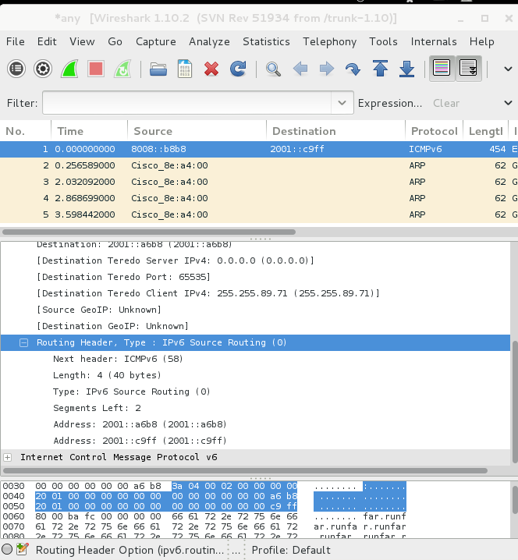

**IPv6HopByHop Script**

#! /usr/bin/env python

#Set log level for Scapy Warnings

import logging

logging.getLogger("scapy").setLevel(1)

from scapy.all import *

r = IPv6(dst='2001::a6b8', src='8008::b8b8')

payload = "far.run" * 50

s = ICMPv6EchoRequest (data=payload)

q = ("A" * 200)

t = IPv6ExtHdrHopByHop(options=PadN(optdata=q))

packet = r/t/s

packet.show2()

send(packet)

**IPv6HopByHop Run**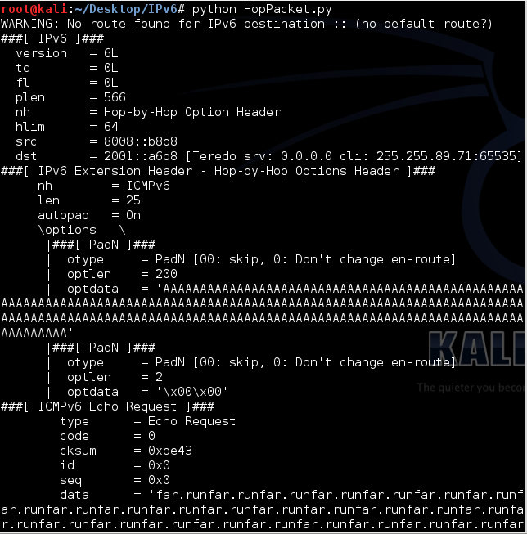

**IPv6HopByHop Wireshark Capture**

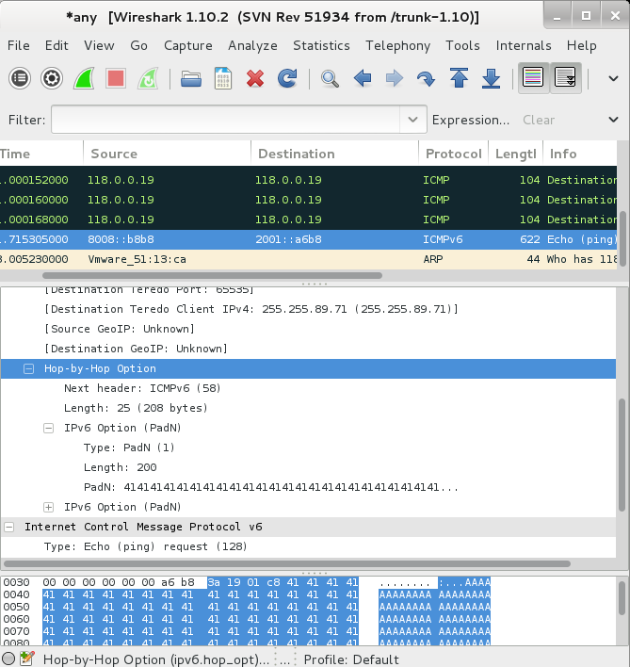

**IPv6FragmentationHeader**

#! /usr/bin/env python

#Set log level for Scapy Warnings

import logging

logging.getLogger("scapy").setLevel(1)

from scapy.all import *

a = IPv6ExtHdrFragment(nh=44, offset=100, m=1)

b = IPv6(dst='2001::a6b8', src='8008::b8b8')

payload = "far.run" * 50

y = ICMPv6EchoRequest (data=payload)

packet = b/a/y

packet.show2()

send(packet)

**IPv6FragmentationHeader Run**

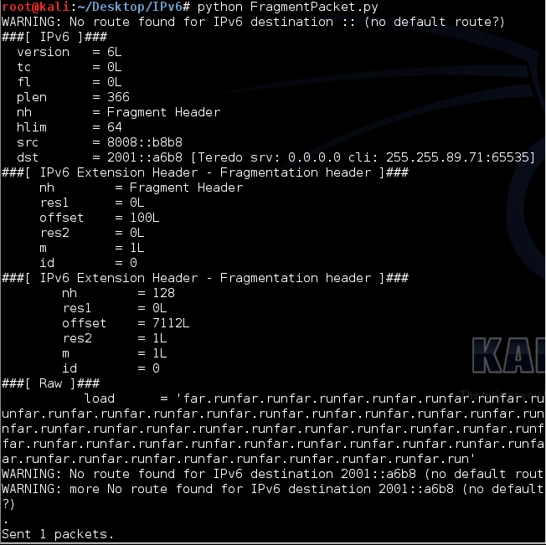

**IPv6FragmentationHeader Wireshark Capture**

